WEEK TWO: WE HONOR OUR LADY
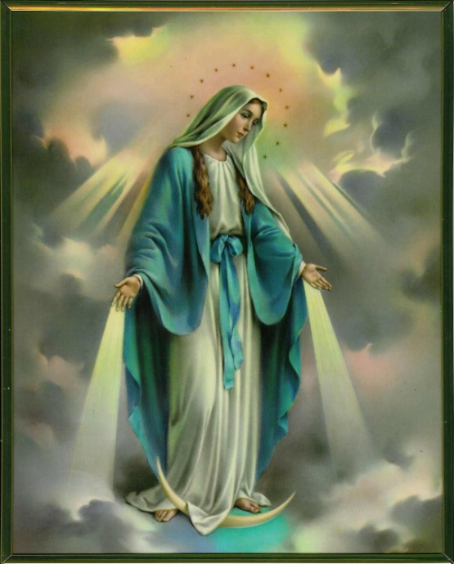
Scripture: In the sixth month the angel Gabriel was sent by God to a town in Galilee called Nazareth, to a virgin engaged to a man whose name was Joseph, of the house of David. The virgin’s name was Mary. And he came to her and said, “Hail, full of grace! The Lord is with you.”(Luke 1:26-28
Pray Together: In the Name of the Father, and of the Son, and of the Holy Spirit. Amen
Hail Mary full of Grace, the Lord is with thee.
Blessed are you amongst women and blessed is the fruit of thy womb Jesus.
Holy Mary, Mother of God,
pray for us sinners now and at the hour of our death
Amen.
Video Lessons
Story of Mary
What Makes Sunday Special?
Story Time: Our Lady's Wardrobe Grades Pre-5

Worship Music

We are Rosary Children Song Grade Pre-3

I Wanna Say Yes Grades Pre-4

Hail Mary in Sign Language Grade 1-5

Optional Activities
Rosary Rings Grades Pre-5
Mini Grattos Grades 1-5
How to Make a Sliding Ladder Rosary Grades 2-5
Blessed Mother Luminary Craft: Our Lady Color Page.pdf
Simply invite your child to color Our Lady and cut out her silhouette leaving tab on the bottom. Wrap the tab around a small battery operated tea light. Invite your child to place Our Holy Mother in their sacred prayer space.
Mini Marian Garden Make a mini succulent or terrarium garden to honor Our Lady in your home.
Joyful Mysteries Cards
Glorious Mysteries Cards
Luminous Mysteries Cards
Sorrowful Mysteries Cards

Family Service Project
Donate baby items to the Bethesda House in support of single mothers and in honor of them saying Yes to God as Mary did. Donations can be left in the church hall throughout the month of October. Some suggestions: Diapers, wipes, baby wash, disinfecting wipes, hand sanitizers and hand soaps.Pray a novena with Our Lady for the health of pregnant women and their unborn babies and for the protection and health of their families. One Our Father, Three Hail Mary and One Glory Be for nine consecutive days.
Did you know that there are seven feast days on which the Church honors Mary?
Mary, Mother of God- January 1
The Annunciation of Our Lord –March 25
The Visitation of the Blessed Virgin-May 31
The Assumption of the Blessed Virgin-August 15
The Birth of Mary-September 8
Immaculate Conception of the Blessed Virgin Mary –December 8
Our Lady of Guadalupe-December 12

SAINTS WE HONOR IN OCTOBER

St. Faustina October 5

St. Teresa of Avila October 15

