WEEK FOUR: JESUS SENDS US HIS SPIRIT
Scripture: If you love me, you will keep my commandments. And I will ask the Father, and he will give you another Advocate to be with you always, the Spirit of truth, which the world cannot accept, because it neither sees nor knows it. But you know it, because it remains with you, and will be in you. (John 14:15-17)
Pray Together: In the name of the Father, and of the Son, and of the Holy Spirit. Amen Come, Holy Spirit, fill the hearts of your faithful and kindle in them the fire of Your love. Send forth Your Spirit and they shall be created, and You shall renew the face of the earth. O God, who by the light of the Holy Spirit, did instruct the hearts of the faithful, grant that by the same Holy Spirit, we may be truly wise and ever rejoice in His consolations, through Christ our Lord. Amen
Videos
From the Bible Pentecost
The Greatest Commandment

Worship Music

To The Sky

Optional Activities: See Below

Balloon Fun: page 3

Silly Dough Trio: page 4

Going on a Wind Hunt!: page 5

Coloring Page

Holy Spirit : page 6

Family Service Project

The season of giving: Help us to shower our Saint Christine’s Senior Citizen shut-ins with love during the Christmas Season through Saint Christine’s Giving Tree. We will be collecting items from mid-November through Dec. 7th. Please drop off your gifts in the Parish Hall.

Grade One: food cards

Grade Two: games and puzzles for seniors: Sudoku, deck of cards, puzzles, adult coloring books and colored pencils.

Grade Three: gifts for senior women; slippers, socks, lap blankets, lotions, tea, cocoa and hard candy.

Grade Four: books of stamps

Grade Five: gifts for senior men; underwear, slippers, socks, hard candy, lap blankets, coffee and cocoa.

Pray a novena with Blessed Carlo Acutis who was just recently beautified. Carlo died in 2006 of leukemia at the age of 15. He was a gamer and a computer programmer. He had a special devotion to Eucharistic miracles and promoted Eucharistic miracles through a website he developed. He has been appointed the Patron Saint of the Internet. Please read about his story below. Pray one Our Father, three Hail Mary’s and One Glory Be for three consecutive days. Simply pray that you too come to know and love Jesus through His gift of Eucharist and that you use the internet only for God’s good. Blessed Carlo, pray for us.

Saints We Honor
Blessed Carlo Acutis
Blessed Carlo Acutis (scroll down to the third video “Rome Reports”, a more detailed account of his life)

Did you Know?
To be canonized a Saint, a person needs to have two miracles attributed to their intercession to be beautified (the last step before being canonized a Saint). The person needs a second miracle to be canonized a Saint. Blessed Carlo Acutis’ first miracle was attributed to the healing of a Brazilian child of a rare pancreatic disorder.

2
Balloon Fun Grades Pre-Three
Materials: Balloons (all the same color)
Depending upon your child’s age, give them a balloon to blow up or blow up a balloon for them. Invite them to let go of their balloon at the same time. Watch them go!
Ask:
When you let go did your balloon stay in one place?
No, it flew somewhere didn’t it? That is like the Holy Spirit.
The Spirit is always active, always on the move.
And when you let go did you know where your balloon was going to end up?
Do you know which one was yours?

That is like the Holy Spirit. The Spirit is unpredictable, that means we don’t know what the Spirit is going to do or where the Spirit is going to be. And often the Spirit surprises us in exciting and wonderful ways.
Or………..

Wind Experiment Grades Pre-Five
Materials : Empty bottle, Balloon, and Bowel of hot water
Invite your child to place the balloon on top of the bottle and show them that the only thing inside the bottle is air. Set the bottle in a bowl of hot water and watch the balloon inflate as the water heats the air.
Say:
The warmth of your kindness is the spirit radiating from your heart filling the world with God’s love.

3
SILLY DOUGH TRIO
Kids will make putty dough using three ingredients, which will each become unrecognizable, though still present.
What you will need:
- Bible
- 1 cup of Elmer’s white glue per group of 4 kids
- ¾ cup of warm water per group
- ½ tsp of Borax
- food coloring (optional)
- bowl
- 1 large spoon
SAY: One of the coolest things about God is that God knew we’d need help but forget to ask sometimes. The Holy Spirit is everywhere, both in us and on earth. But you can’t look in the mirror and see the Holy Spirit. It may be easy to forget the Holy Spirit is even there because we don’t see him.
Read aloud Romans 8:11 and John 14:16-17.
SAY: These words from the Bible promise that the Holy Spirit will live in us. But how is it possible to have something inside you that you can’t see? You can see every other part of your body, right? Let’s try an experiment that might help us understand a little better. We’re going to make silly dough right now
SAY: Let’s start by mixing all our ingredients together. First, pour in the glue. Then add the other ingredients, one at a time.
Invite the kids to mix the ingredients, and then show them how to knead the mixture well. Once the mixture is pliable, let kids each have a piece to play with. Invite them to try to create something that looks like their version of the Holy Spirit.
- Where is the glue now? the water? the Borax powder?
- Why do you think you can’t see the individual ingredients?
- How are the ingredients in the dough like or unlike how the Holy Spirit lives in each of us?
SAY: Even though the separate ingredients aren’t visible, we know they’re still in your silly dough. It’s the same for us. Once we get with Jesus, choosing to believe in and follow him, the Holy Spirit is within us. We’ll never be the same, just as the individual ingredients won’t be the same. But we’ll be much, much more.
4

Go on a wind hunt!

Tell your children you are going to go outside to catch some wind. Bring large trash bags outside and invite your children to run into the wind. Tie their bags once they are filled with air.

Ask:
- Did you catch any wind?
- Can you see the wind?
- Can you feel the winds power?

Tell your children that the Holy Spirit is like the wind. The Spirit is seen as “wind” in the Bible and is often compared to breath. You can’t see the Holy Spirit but you can feel the Spirit’s power, you can sense His presence, or even feel the tugging at your heart to be kind and to love. Tell your children that their hearts were filled with the Holy Spirit at their baptism.

Another Idea: Use a sheet and invite two children to hold onto to either end as they run into the wind to sense its power.

5

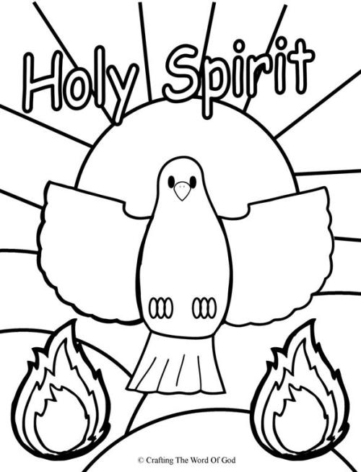
6

