WEEK THREE: JESUS OUR SAVIOR
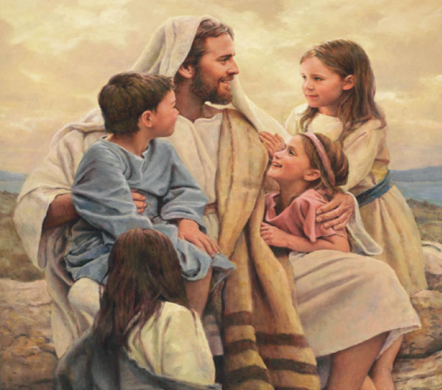
Scripture: Jesus, though he was in the form of God, did not regard equality with God as something to be exploited, but emptied himself, taking the form of a slave, being born in human likeness. And being found in human form, he humbled himself and became obedient to the point of death – even death on a cross. (Philippians 2:6-8)
Pray Together: In the name of the Father, and of the Son, and of the Holy Spirit. Amen
Dear Sacred Heart of Jesus, I love You so much and I give You my heart. Help me to love God. Help me to love my neighbor as a child of God. Help me to love myself as a child of God. AMEN
Video Lessons
The Story of Jesus
Worship Music
Yes Jesus Loves Me
Optional Activities
Three fun and interactive activities to teach about Jesus: Preschool-1
Jesus, Fisher of Men Activities
Sacred and Immaculate Heart

Sacred Heart of Jesus Scavenger Hunt: Visit local churches in hunt of statues of the Sacred Heart of Jesus. Some churches have candles you can light for your family as you offer a prayer. St. Anne’s by the Sea in Marshfield and Holy Ghost in Whitman have votive candle prayer spaces. A challenge: Can you find the Sacred Heart of Jesus statue at St. Christine’s Parish?
Family Service Projects
A long standing tradition at Saint Christine’s has been to support Saint Matthew’s Parish in Dorchester by purchasing blankets for the needy. We invite you to donate any size new or used blanket and drop it off in the Parish Hall beginning November 1st through November 13th. Saint Christine’s will celebrate Blanket Sunday on the weekend of the 15th.
Make small breads for Senior Citizens at Gracie Ryder
Pray a Novena with Saint Vincent de Paul asking God to open your heart to answer God’s call to help the poor as Saint Vincent did. Simply pray One Hour Father, Three Hail Mary’s and One Glory Be for nine consecutive days. Saint Vincent de Paul, pray for us.

Coloring Page – see below

Jesus and the Children
Jesus and the Fishermen
Did you know?
The night before Halloween is the night before All Saints Day and is called “All Hallows Eve”. Halloween was instituted by Pope Gregory lll in the early eighth century. “Hallow” is another word for a Saint or a holy person. We even say it in the Our Father-“Hallowed be thy name”. Halloween reminds us that we are all called to be holy and to be saints and to be God’s special disciples. We, as Catholics, celebrate All Saints Day on November 1st. All Saints Day is an occasion when we honor special people who spent their life showing their love for Jesus by doing good things for others — these people were so kindhearted and selfless that the Church made them saints.

Saints We Honor in November
In celebration of All Saints Day, let’s take the opportunity to honor our own patron saint by seeking their help in prayer and protection. Our first patron saints are our named saints, if we were given saints’ names, or can be the name of the saint that feast day falls on our birthday. Although we do love St. John Chrysostom’s perspective:
“So let the name of the saints enter our homes through the naming of our children, to train not only the child but the father, when he reflects that he is the father of John or Elijah or James … Do not because it is a small thing regard it as small; its purpose is to succor us.”
* Just an idea………….Print a picture of your Patron Saint and add it to your Sacred Space.

